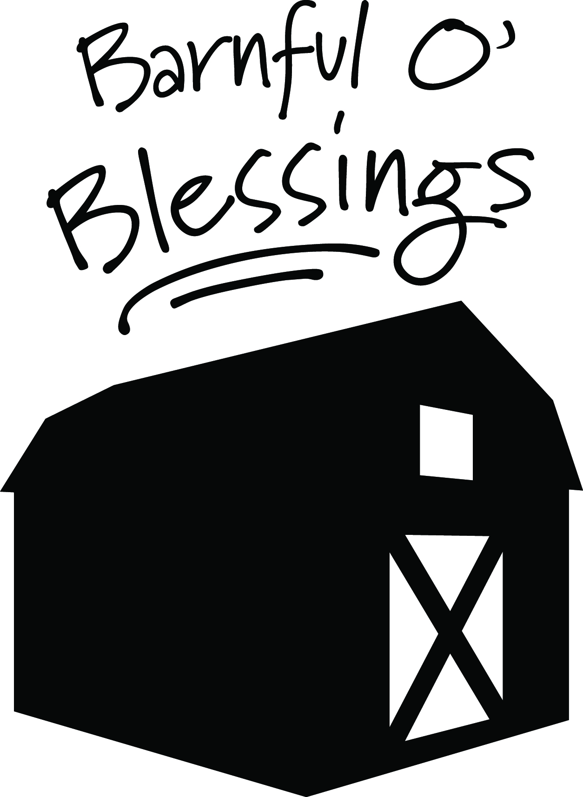
Craft Market and Annual Holiday Book Sale 1768 Dryden Road, Freeville, NY

Dear Crafter/ Vendor,
Thank you so much for your interest in our “Barnful O’ Blessings and Bales O’ Fun” Craft Market. This event will take place on Saturday, October 31 , 2015 from 9:30am-4:00pm. The Craft Market will be hosted alongside our annual Holiday Book Sale, Bake Sale, Soup Café, and our new “Bales O’ Fun” Family Friendly Event. All of this will be located at the Covenant Love Community School “The Barn”, 1768 Dryden Road, Freeville. This is a prime location on Rte 13 between Cortland /Dryden and Ithaca, less than 15 minutes from downtown Ithaca.
Attached is a craft/vendor application and list of regulations. Our desire is to make the whole event enjoyable, smooth, and successful for everyone involved!
Please submit your application as soon as possible for review, before October 1st. Also, please sign and date the regulations form and include your payment made out to CLCS. As in years past, this will be a juried craft show. If you are not selected, we will notify you through email as soon as possible and cancel your check.
Thank you. We look forward to hearing from you!
Kyle, on behalf of the Craft Market Committee
*Please submit all forms and payment, along with any correspondence or inquiries to the attention of: Ms. Kyle Hamilton
c/o CLCS
1768 Dryden Rd.
Freeville, NY 13068
office@clcschool.org
607-347-4413

Guidelines and Policies:
Vendors/crafters will be responsible for providing their own tables/displays that fit properly within the allotted space. You are also responsible for your own table coverings and space décor that are pleasing to the eye. We are moving outdoors this year! There will be large overhead tents provided, but the tents do not have sides, so please take this into consideration when selecting décor. Our move to outdoors will also mean that there will be no access to electricity available.
Vendors/crafters are responsible for providing their own “bank”, as each booth will be receiving payment for their own items.
Vendors/crafters are responsible for set up. We ask that you be ready to go by 9:15 am Saturday, Oct. 31st, and remain set up after the close of the show, until 4:15pm. At that point, we will work with you to help make loading out as smooth as possible.
Applications will be reviewed by our jury and we will notify you of your acceptance as soon as possible. If we are unable to accept your application for any reason, you will also be notified as soon as possible by email and your check will be canceled. Otherwise, all payments are non- refundable. (If you would like your check returned to you, please include a self-addressed stamped envelope along with your application.)
You will be contacted approximately a week in advance of the show to arrange an appointment for Friday, October 30th to unload and set up. We will have someone available to help you carry your items. We ask that you park your vehicle in our lot before arranging your items and decorating your space.
We will be advertising this day publicly but ask that you please help us in getting the word out!
Thank you very much for your interest in our

Craft Market 2015
Craft Market 2015 Application Form
Crafters’ Name: (please print) ___________________________________________________
Business Name: ______________________________________________________________
Address: ____________________________________________________________________
City: _______________________________________ State: _______ Zip Code: ___________
Home Phone: ________________________ Cell Phone: _____________________________
E-Mail: _________________________________Website: ____________________________

List a full description of the craft(s) that you will be selling. (Use additional page if necessary.) Please include photos, if possible.
_________________________________________________________________________
_________________________________________________________________________
_________________________________________________________________________
_________________________________________________________________________

Are your crafts handcrafted and made by you? _________
Is the craft in its entirety made by you? __________
Please describe your space set up________________________________________________
_________________________________________________________________________

Space fees go directly to Covenant Love Community School
9’ x 5’ space under tent (approximation) *$20.00(per space) __________

Crafter acknowledgement:
Submission of an application does not guarantee acceptance, the right to participate, or the reservation of booth space for the Barnful O’ Blessings and Bales O’ Fun Craft Market. Your signature certifies that you have read the guidelines and policies and you agree to adhere to them. In addition, you agree to assume all responsibility for loss due to theft or damage of all items you are selling or any damage you may cause to the CLC School facilities.

I have read all information, guidelines, and policies and agree to abide by the terms and conditions set forth therein.

Signature: ____________________________________ Date: _____________________

Crafter Checklist:
􀂇 Check made payable to CLCS
􀂇 Completed application
􀂇 Signed acknowledgement
􀂇 Self-addressed stamped envelope (If you would like your canceled check returned to you)

Once complete, please submit all of the above to:
Kyle Hamilton
c/o CLCS
1768 Dryden Rd.
Freeville, NY 13068

